CS 255 System Design Document Template

This template lays out all the different sections that you need to complete for Project Two. Each section has guidance to prompt your thinking. You will need to continually reference the interview transcript as you work to make sure that you are addressing your client’s needs. There is no required length for the final document. Instead the goal is to complete each section based on what your client’s needs are. Remove this note when you are finished, and replace all bracketed text with the relevant information.

UML Diagrams

UML Use Case Diagram

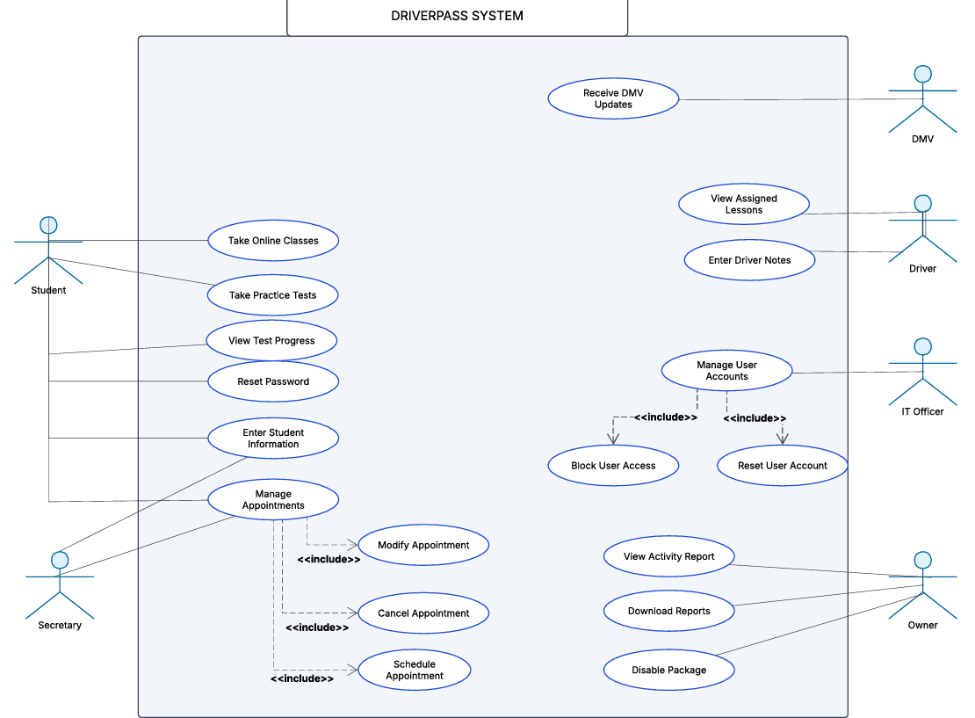

UML Activity Diagrams
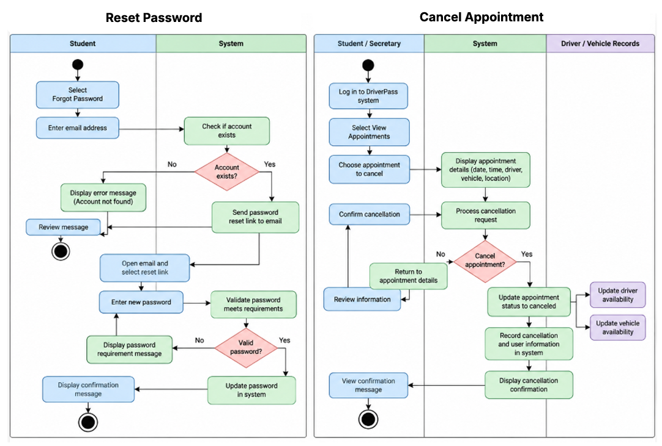

UML Sequence Diagram

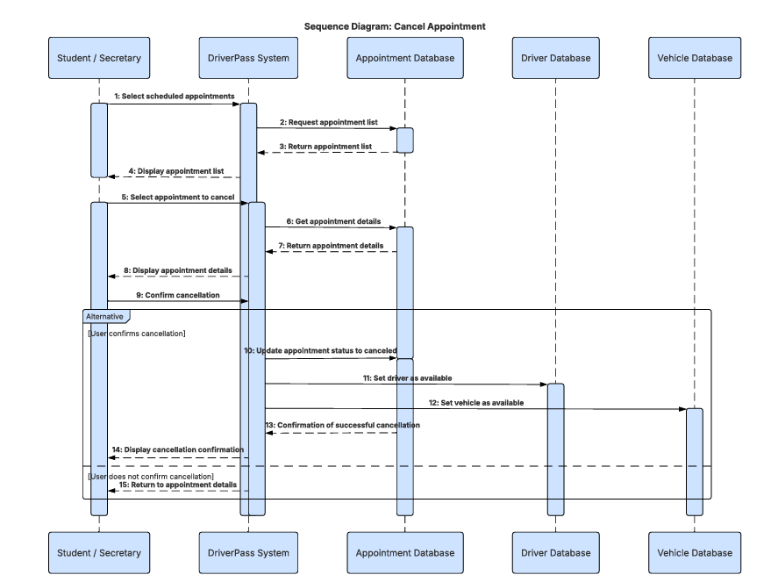

UML Class Diagram
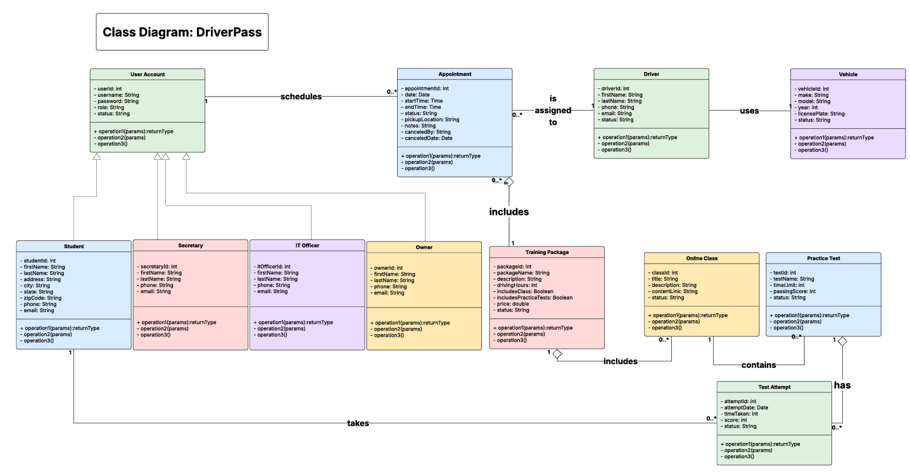

Technical Requirements

The DriverPass system will require the appropriate hardware, software, and infrastructure to enable students and employees to access its features safely and seamlessly. Based on the UML diagrams and the DriverPass interview, the system will need the following technical requirements:

Hardware- DriverPass will need computers or laptops for the secretary, owner, and IT officer to manage appointments, student accounts, and reports. Students should be able to access the system using computers, tablets, or smartphones. Drivers will also need access to a device to view their assigned lessons and enter notes after each session.

Software - This needs to be a web-based system so users can access it through a browser without installing additional software. It will also need a database to store student information, appointments, training packages, driver and vehicle assignments, and practice test results. The system should allow students to reset their passwords and employees to access only the information needed for their roles. It should also support downloading reports that can be opened in Excel.

Tools and Security - The development team can use tools such as Lucidchart to create UML diagrams and a programming environment to build and test the system. Security measures should include password protection, encrypted connections, and different access permissions for students and employees. The system should also keep an activity log showing who scheduled, modified, or canceled appointments and when those changes occurred. The owner can review activity reports when needed.

Infrastructure - DriverPass will need a reliable internet connection and a cloud-based hosting service to store and manage its information. Cloud hosting would allow users to access the system from different locations while reducing the need for DriverPass to maintain its own servers. The cloud service should also provide regular backups and protection against data loss. Since DriverPass wants to receive updates from the DMV, the system will need a way to connect to an available DMV information service so that changes to rules, policies, and practice test questions can be received and reviewed.

Overall,, these requirements will help DriverPass manage its daily operations, secure student information, and provide students with access to driving lessons and online training.

